3.3 Frame [Jacob Hawley]

The frame of the Vehicle must be able to support the weight of the rider, outer shell, and interior components. With all the weight on the frame the wheel placement plays an important role. The frame of the Vehicle must be designed in such a way that the rider is always safe. The Vehicle must not tip or flip over in anyway. Also, the rider must be able to maintain visibility and handling in any situation. To make sure that the Vehicle is the safest that it can be, two engineering principles were examined. The first principle was *force distribution.* Within force distribution two aspects were looked at: wheel and seat placement. The second principle *is centre of mass*, which was determined by the height of the seat from the ground.

* + 1. Force distribution

3.3.1.1 Wheel placement

Wheel placement will be determined based on the length of the *wheel base*. A wheel base that is too long results in the Vehicle having reduced handling. It will also cause the Vehicle to have a greater *turning radius*. The long wheel base will result in the most unstable Vehicle: the longer the wheel base the easier it is for the bike to tip over or roll. On the positive side, a long wheel base provides a more comfortable and smooth ride since the rider is further away from the wheels. Figure 1 is an example of a recumbent bike with a long wheel base. Although the bike in the figure is not a tricycle it depicts what a long wheel base may look like.

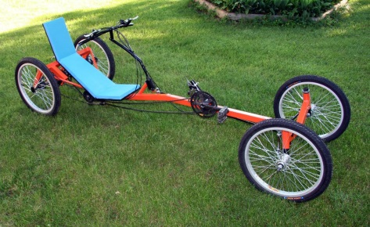

Figure 1: Long Wheel Base [1]

The short wheel base leads to a sturdier Vehicle with better handling, and a smaller turning radius. The rider is almost on top of the front wheels with a short wheel base, resulting in a bumpier and uncomfortable ride. Also, since the rider is almost on top of the front wheels, the rear wheel will not have enough weight on it. A lack of weight on the rear tire will cause the tire not to gain enough *traction* and spin out, or the rider could flip forward when applying the brakes. Look at figure 2 for an example of a short wheel base.

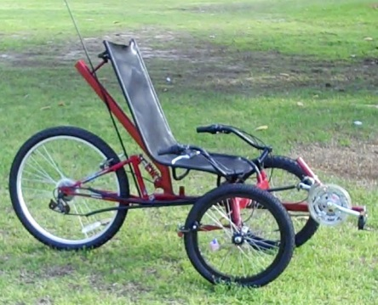

Figure 2: Short Wheel Base [2]

Therefore the ideal wheel base is 120 cm [3] to best suit the Vehicle based on the dimensions stated in section 3.1, Shape and Size. This distance is chosen to ensure maximum comfort, handling, and safety.

* + - 1. Seat placement

Where the seat is placed is also a big factor in force distribution as the rider may be very heavy and is directly on top of the frame. A seat that is too close to the rear tires can result in the bike flipping backwards while riding. A seat that is too close to the front tires could cause the bike to flip forward when braking. If the seat is too close to either tire the rider could be uncomfortable. If the seat is too close to the rear the bike will be less sturdy and could tip easier. The best seat placement is the ratio of 70/30, measured front tires to back tire [4]: 70 % of the distance towards the front tires if measuring the wheel base starting at the back tire. Based on the wheel base length of 120cm the seat will be 84 cm from the rear tire towards the front. Since the number can vary slightly, and is just the most ideal placement, the seat should be able to slide forward and backwards to tailor to the rider’s comfort, which is examined more in the Interior, section 3.4. An example of the ideal seat placement can be seen in figure 3.

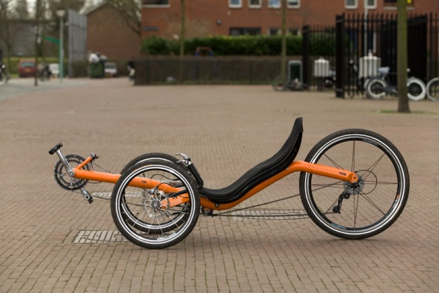

Figure 3: Seat Placement [5]

* + 1. Centre of Mass

The centre of mass plays a very important role in how sturdy the Vehicle is. If the centre of mass is low enough it is very unlikely the Vehicle will tip, regardless of wheel and seat placement. A centre of mass that is too low can result in a decrease in visibility and safety. Since centre of mass is dependent of the seat height from the ground the frame must be lowered or lifted in order to have an ideal centre of mass. If the wheel base length and seat placement are not ideal the centre of mass should be below the centre of the tires, but high enough to maintain visibility. Since the wheel base is the ideal length and the seat is in the ideal place the centre of mass can be an equal to the height of the centre of the wheels from the ground and not cause the bike to become unsteady. This can be achieved by putting a bend or curve in the frame within the wheel base. Figure 4 shows a bike with a centre of mass that is higher than the centre of the wheels since the frame does not bend or dip down.

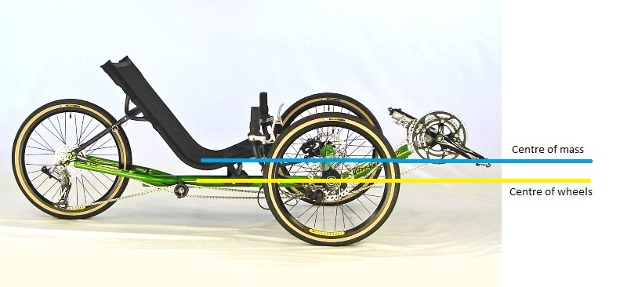

Figure 4: High Centre of Mass [6]

The Vehicle is going to have a seat suspension system, this mean that the frame needs to be lowered to ensure the seat is not higher than the centre of the wheels. Lowering the frame by 10 cm should leave room for the suspension, and it will be practical since the average wheel radius, is around 33 cm.

* + 1. Conclusion

The ideal frame for the Vehicle is one that is sturdy, safe, has good visibility and handling. The force distribution of the Vehicle relies on both wheel and seat placement. The wheel base length is 120cm long and the seat will be placed 84 cm measured from the rear tire towards the front. The centre of mass mostly relies on how high the seat is. Since the wheel and seat placement are ideal the frame will be lowered, allowing space for the suspension and to ensure the seat will be in line with or below the centre of mass of the wheels. With these three placements the bike should be safe and handle with ease. An example of a bike with these conditions can be seen in figure 5.

FIGURE 5 TO BE INCLUDED HERE